ASSIGNMENT-4

DISTANCEDETECTIONUSINGULTRASONICSENSOR

|  |  |
| --- | --- |
| Date | 22October2022 |
| TeamID | PNT2022TMID11064 |
| Name | Neha Mohanan |
| StudentRollNumber | 811519106092 |
| MaximumMarks | 2Marks |

# Question1:

Writecodeandconnectionsinwork forultrasonicsensor.Wheneverdistanceislessthan100cmssend"alert"toibmcloudanddisplayindevicerecentevents.

WOKWILINK:

https://wokwi.com/projects/305566932847821378

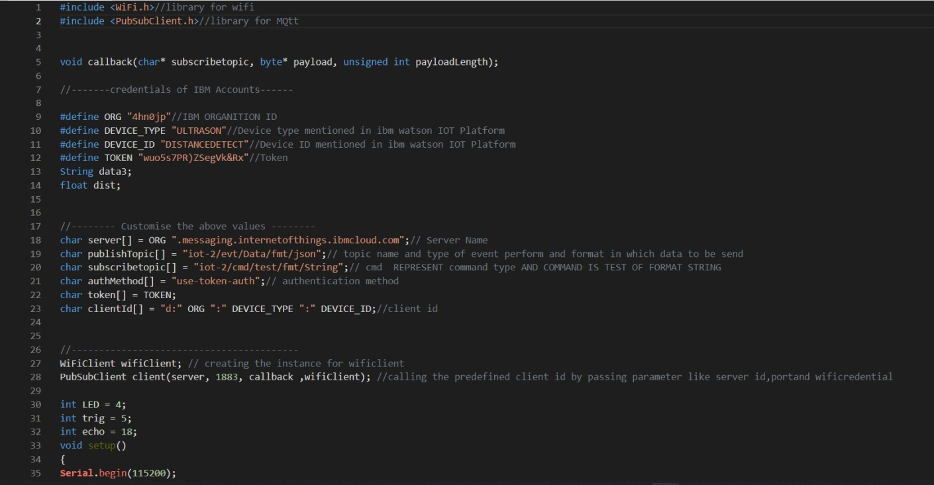CODE:

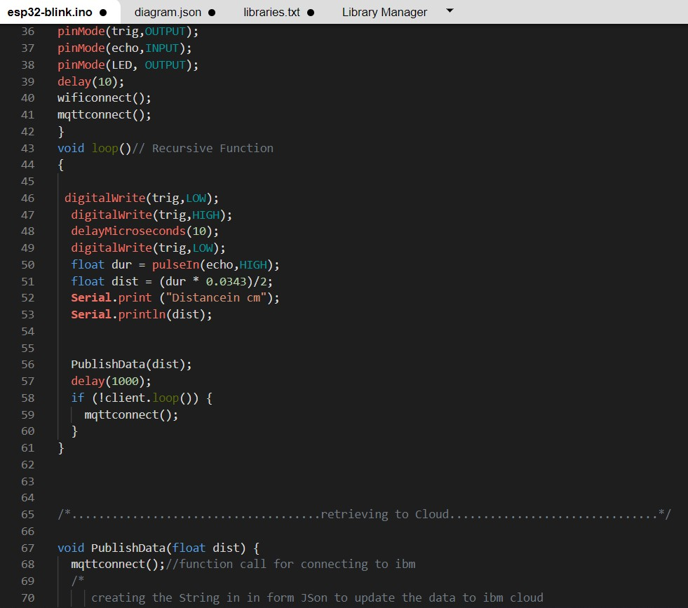

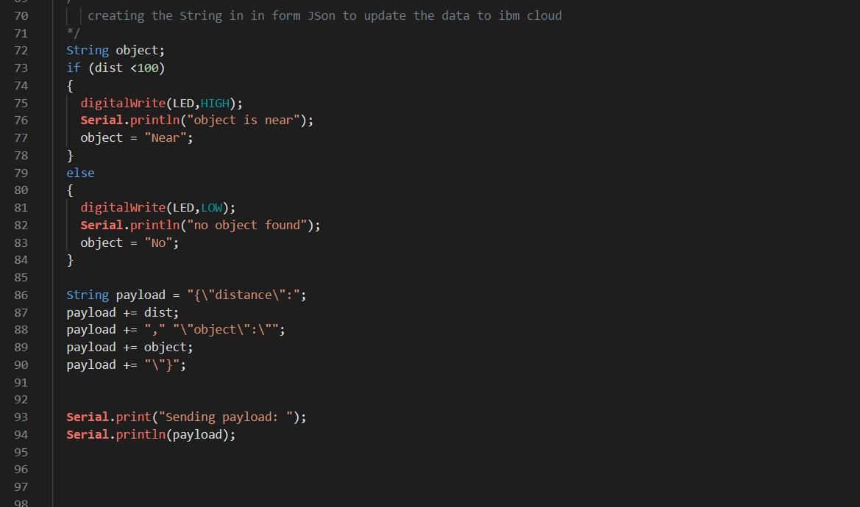

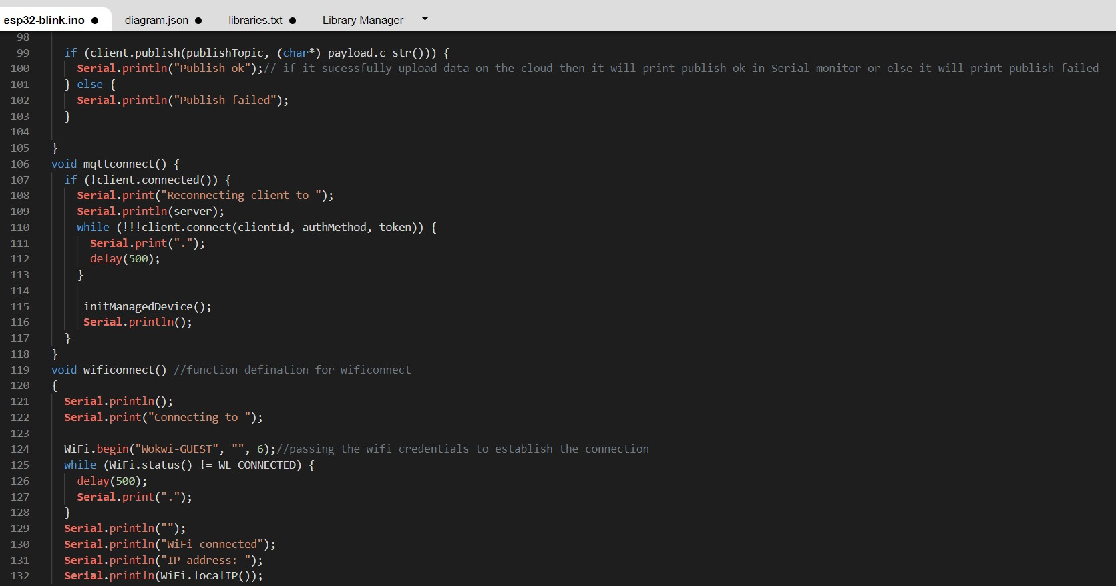

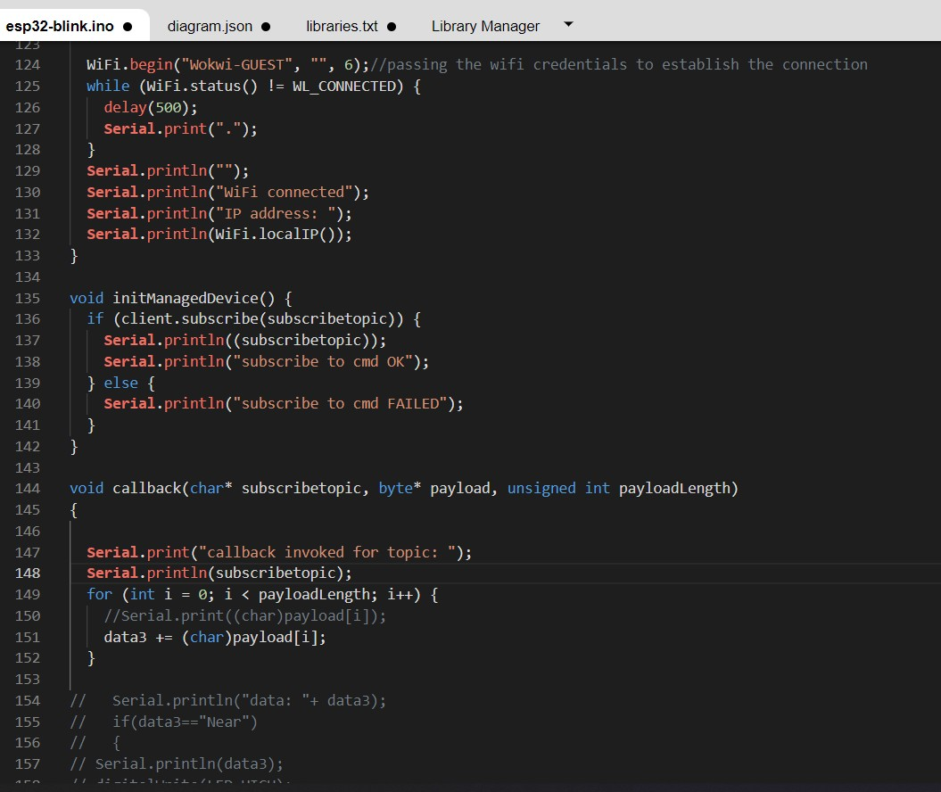

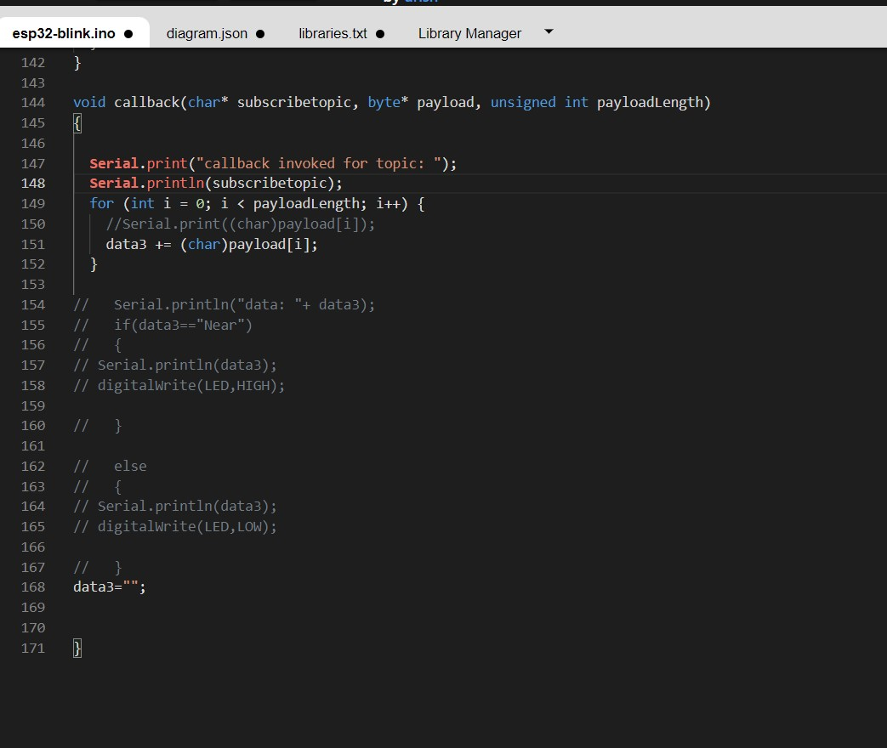

# OUTPUT:

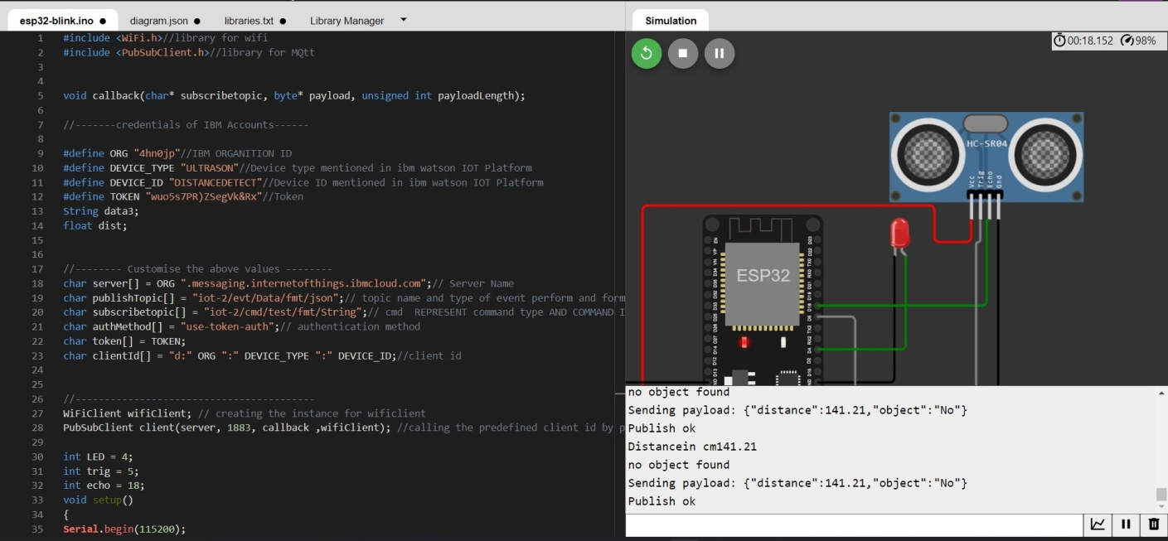

DatasendtotheIBMclouddevicewhentheobjectisfar

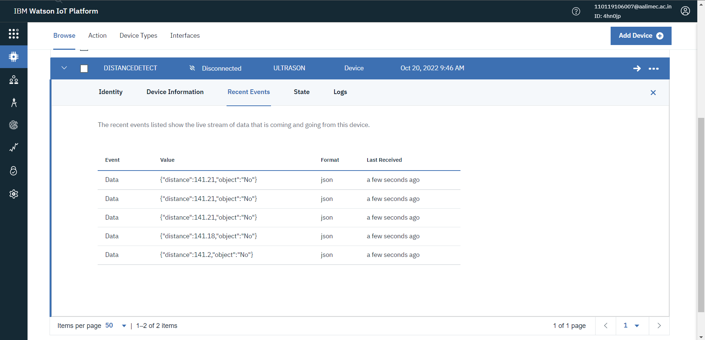

# whenobjectisneartotheultrasonicsensor

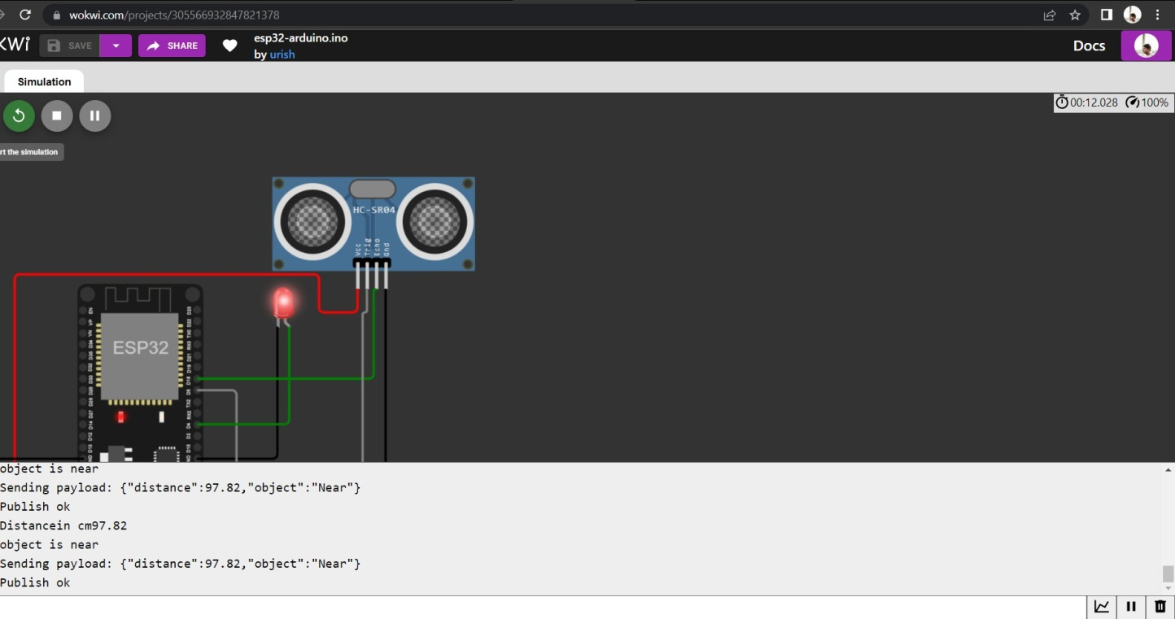

DatasenttotheIBMCloudDevicewhentheobjectisnear

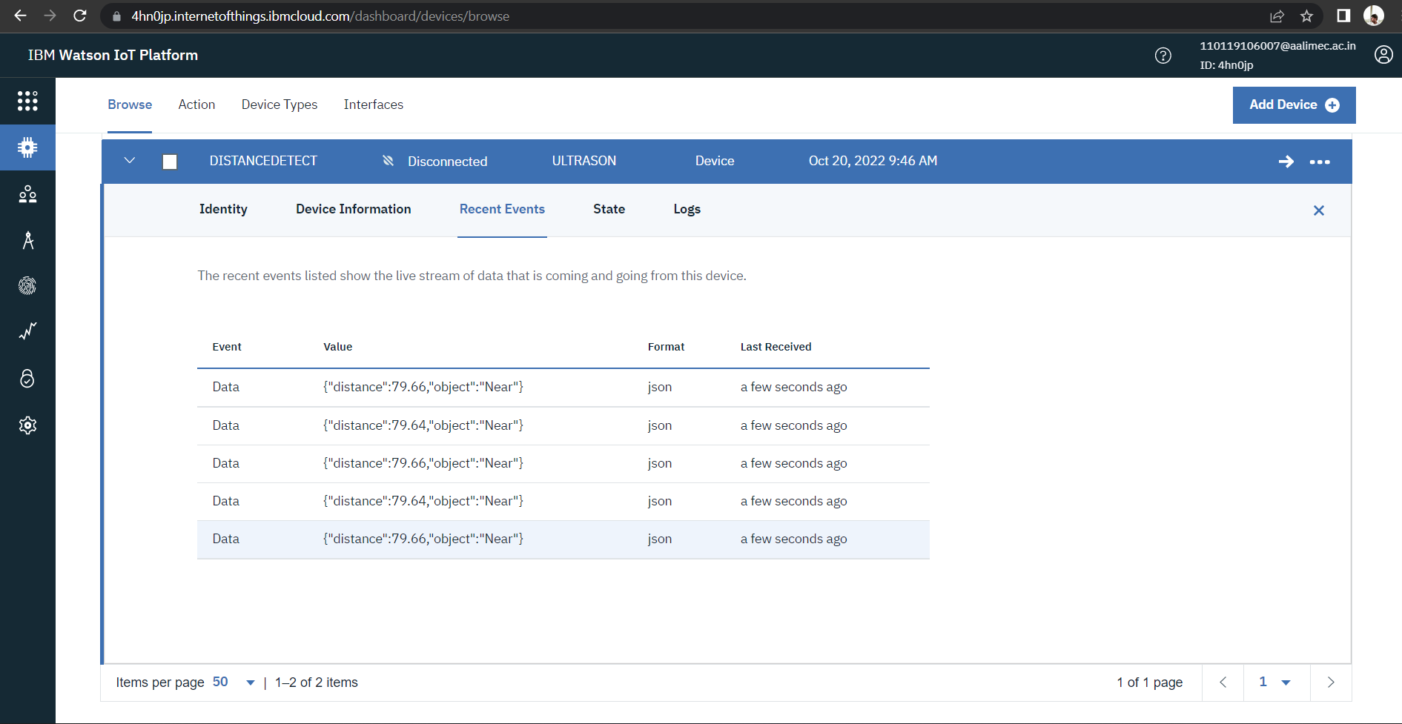

# https://wokwi.com/projects/305566932847821378